Interpreter Architecture
(Source Code → Tokenizer → Parser → Compiler → Bytecode → PVM → OS)
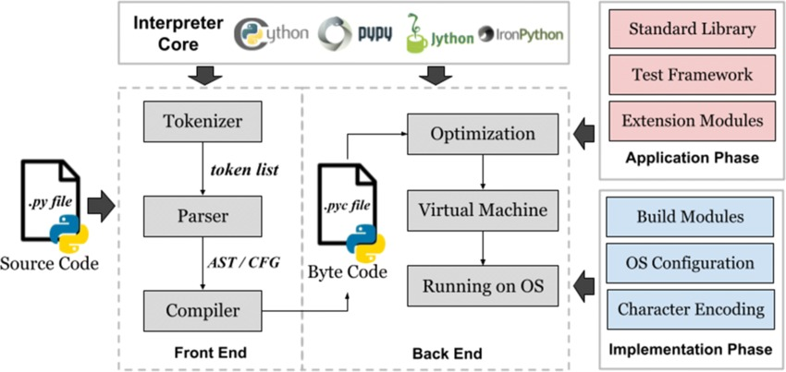

1. Source Code (.py file)
num = int(input("Enter a number: "))

if num % 2 == 0:
print("The number is Even")
else:
print("The number is Odd")

FRONT-END
2. Tokenizer (Lexical Analysis)
What Tokenizer does:
- Breaks source code into tokens
- Tokens are smallest meaningful units
Example line:
if num % 2 == 0:
Tokens formed:
if | num | % | 2 | == | 0 | :

3. Parser (Syntax Analysis)
What Parser does:
- Checks grammatical correctness of tokens
- Creates Abstract Syntax Tree (AST)
- Verifies indentation and block structure
Checks in this program:
- Correct if–else structure
- Proper colon :
- Proper indentation

4. Compiler (Bytecode Generation)
What Compiler does:
- Converts parsed code into Python bytecode
- Bytecode is low-level and platform independent
- Stored internally as .pyc files
Bytecode includes:
- Input instructions
- Modulus operation
- Conditional jump instructions
- Print instructions
BACK-END
5. Optimization Phase
What happens here:
- Python optimizes execution
- Removes unnecessary steps
- Efficient arithmetic operations
Example:
num % 2

6. Python Virtual Machine (PVM)
What PVM does:
- Executes bytecode line by line
- Produces actual output
Execution flow:
- Reads input number
- Converts input to integer
- Checks remainder
- Executes if or else
- Prints result
This is where the program actually runs

7. Operating System (OS) Interaction
What OS does:
- Handles keyboard input
- Displays output on screen
- Manages memory
In this program:
- OS accepts number from user
- OS prints result on console

8. Final Output
Sample Run:
Enter a number: 10
The number is Even

